BRIDGWATER AND DISTRICT
2021 GRASS KEEP
TO LET – OFFERS INVITED

Location | Acres
Chilton Trinity - Withdrawn | Est. 12.60
Pond & Webb Land, Nr Chilton Trinity | 8.00
Eastside Lane, Knowle, Bawdrip | 0.38

LANDLORD(S): HAGGETT, MR & MRS
TENDER 2 | CHILTON TRINITY – EST. 12.60 ACRES
As marked and coloured red on the location plan. Sold for mowing once/feeding with cattle or sheep from 1st April 2021 to 30th November 2021. Note: A footpath running through the land.

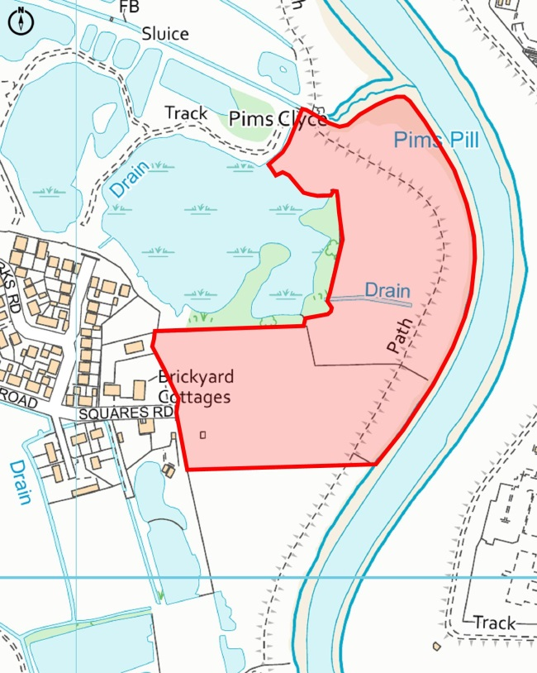

LANDLORD(S): NOTARO, S & NOTARO LIVINGSTONE
TENDER 4 | POND & WEBB LAND, NR CHILTON TRINITY - 8.00 ACRES
As marked and coloured red on the location plan it has a 6 and 2 acre plot. Sold for mowing once/feeding with cattle from 1st April 2021 to 30th October 2020. Note: The pond area will require access to build an attenuation pond at some point in the near future.

LANDLORD(S): NOTARO, S & NOTARO LIVINGSTONE
TENDER 5 | EASTSIDE LANE, KNOWLE, BAWDRIP – 0.38 ACRES
As marked and coloured red on the location plan. Sold for mowing once/feeding with cattle from 1st April 2021 to 30th September 2021.

