FOR SALE BY PRIVATE TREATY

DEVELOPMENT OPPORTUNITY

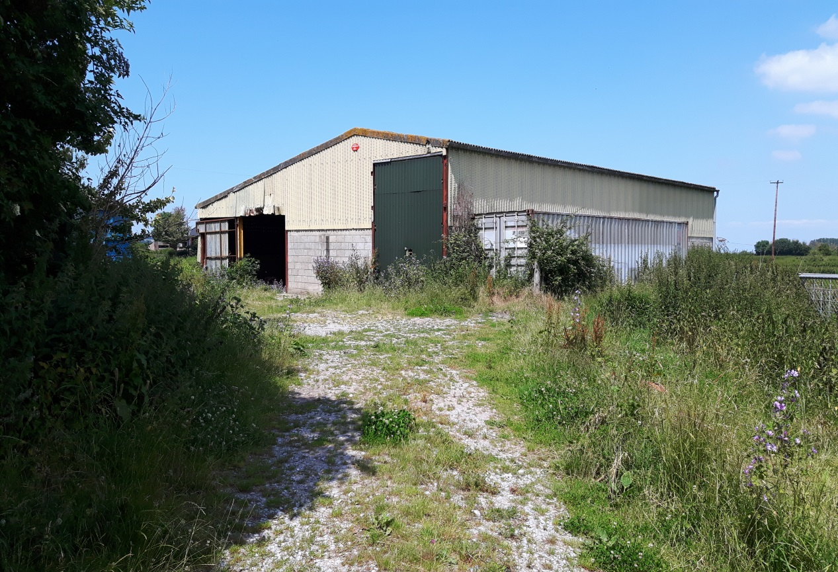

RURAL FARM BUILDING
SET IN THREE QUARTERS OF AN ACRE

WITH PLANNING PERMISSION FOR
CONVERSION INTO TWO DWELLINGS

SITUATED AT

BLAKES ROAD, WEMBDON,
BRIDGWATER, SOMERSET, TA5 2BE

GUIDE PRICE £279,000
FREEHOLD

Description

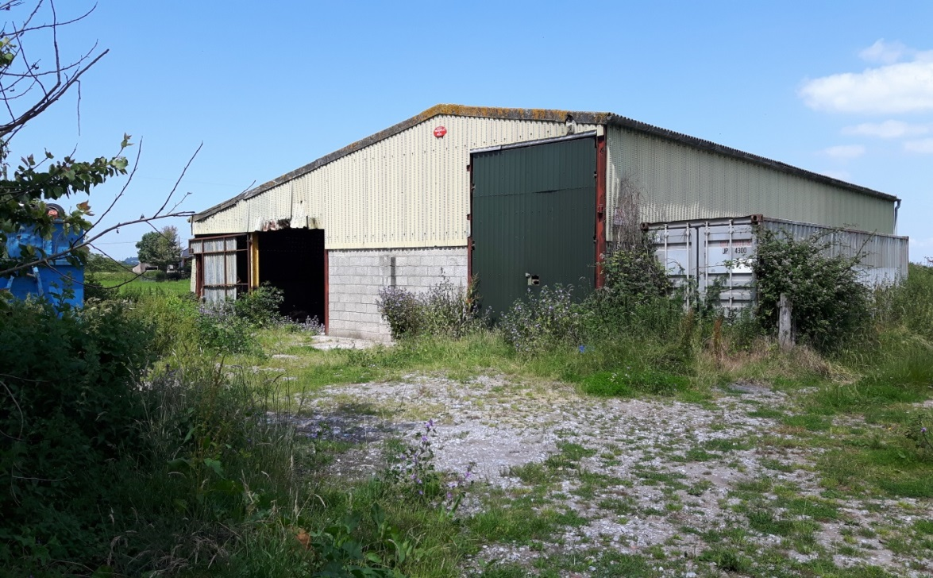

A steel portal framed farm building with part concrete block walls having its own private driveway access from Blakes Lane with the entrance from a short right of way (marked blue on plan)

Located in a rural position just to the north of Blakes Farmhouse.

Sold with the benefit of planning permission (granted on appeal) Reference APP/V3310/W/18/3202405 for “conversion of agricultural building into two dwellings as per planning application submitted to Sedgemoor District Council ref: 51/18/00002 DRT. Appeal decision dated 8th October 2018.

Provided with these particulars for information are a reduced scale copy of the planning submission design drawings.

Also provided with these sales particulars is a proposed sale plan showing the property offered extending to about three quarters of an acre, this includes an area of agricultural pasture which is outside of the area on which planning permission was granted.

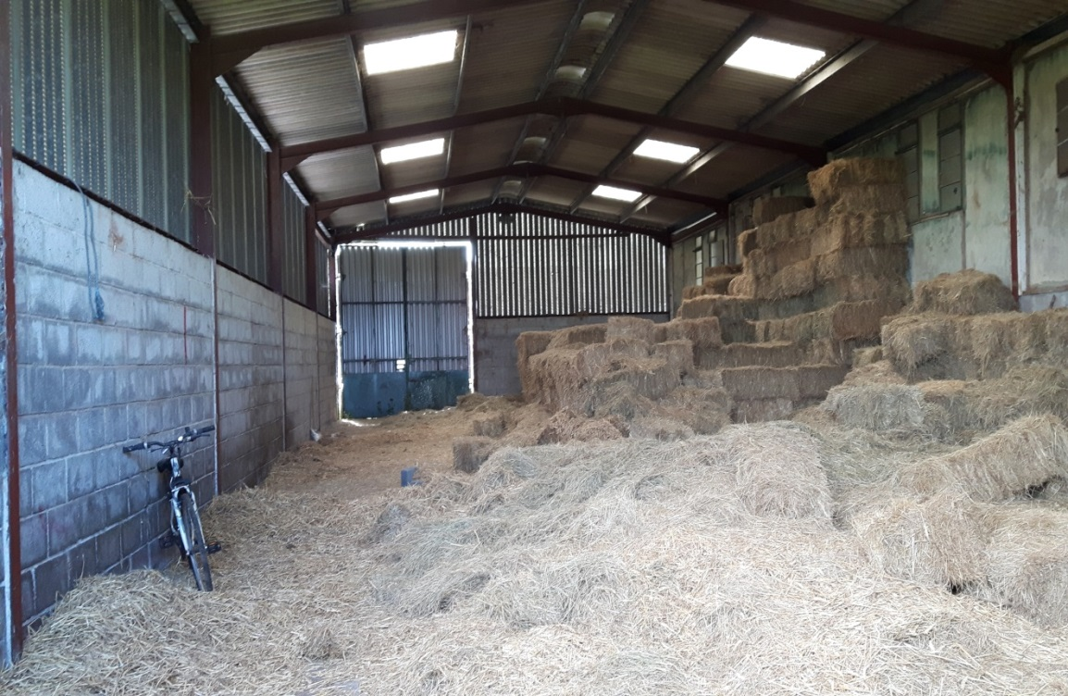

A full size copy of the design drawings may be inspected at Tamlyns, Drawing, Planning & Design Department, 35 Market Street, Bridgwater, TA6 3EP, by prior appointment with James Venton.

The current approved design drawings provide for two x 3 bedroom dwellings with boarded external cladding.

Prospective purchasers should note that an immediate start on conversion could be made on the current design (although separate consent will be needed for Building Regulations). Alternatively purchasers might seek an alternative planning permission (if they require) in terms of design, density etc.

Community Infrastructure Levy
If the current design plans are implemented Sedgemoor District Council have indicated a reduced levy (because of previous agricultural use) with a payable sum of £684.21 with the liability to pay by the developer prior to commencement.

Note Under The Estate Agents Act
Notice is hereby given that a vendor of the above property is an employee of the Selling Agents, Tamlyn & Son Limited.

Viewing
The property may be viewed at any reasonable time. The selling agents will be pleased to meet any interested party on site by prior arranged appointment on 01278 458241 (option 1) or email us on agricultural@tamlyns.co.uk

Important Notice
These particulars are set out as a general outline only for the guidance of potential purchasers and do not constitute an offer or contract or part of the same. All descriptions, dimensions, reference to condition and necessary permissions for use and occupation, warranties and other details are given without responsibility and any potential purchasers should not rely on them as statements or representations of fact but must satisfy themselves by inspection or otherwise as to the correctness of each of them. Any photographs and plans in these particulars are to identify the property to potential purchasers. They do not show the extent of the property and must not be relied upon to be to scale. It should not be assumed that any property has the necessary planning consents, building regulations or other consents.

Proposed Sale Plan

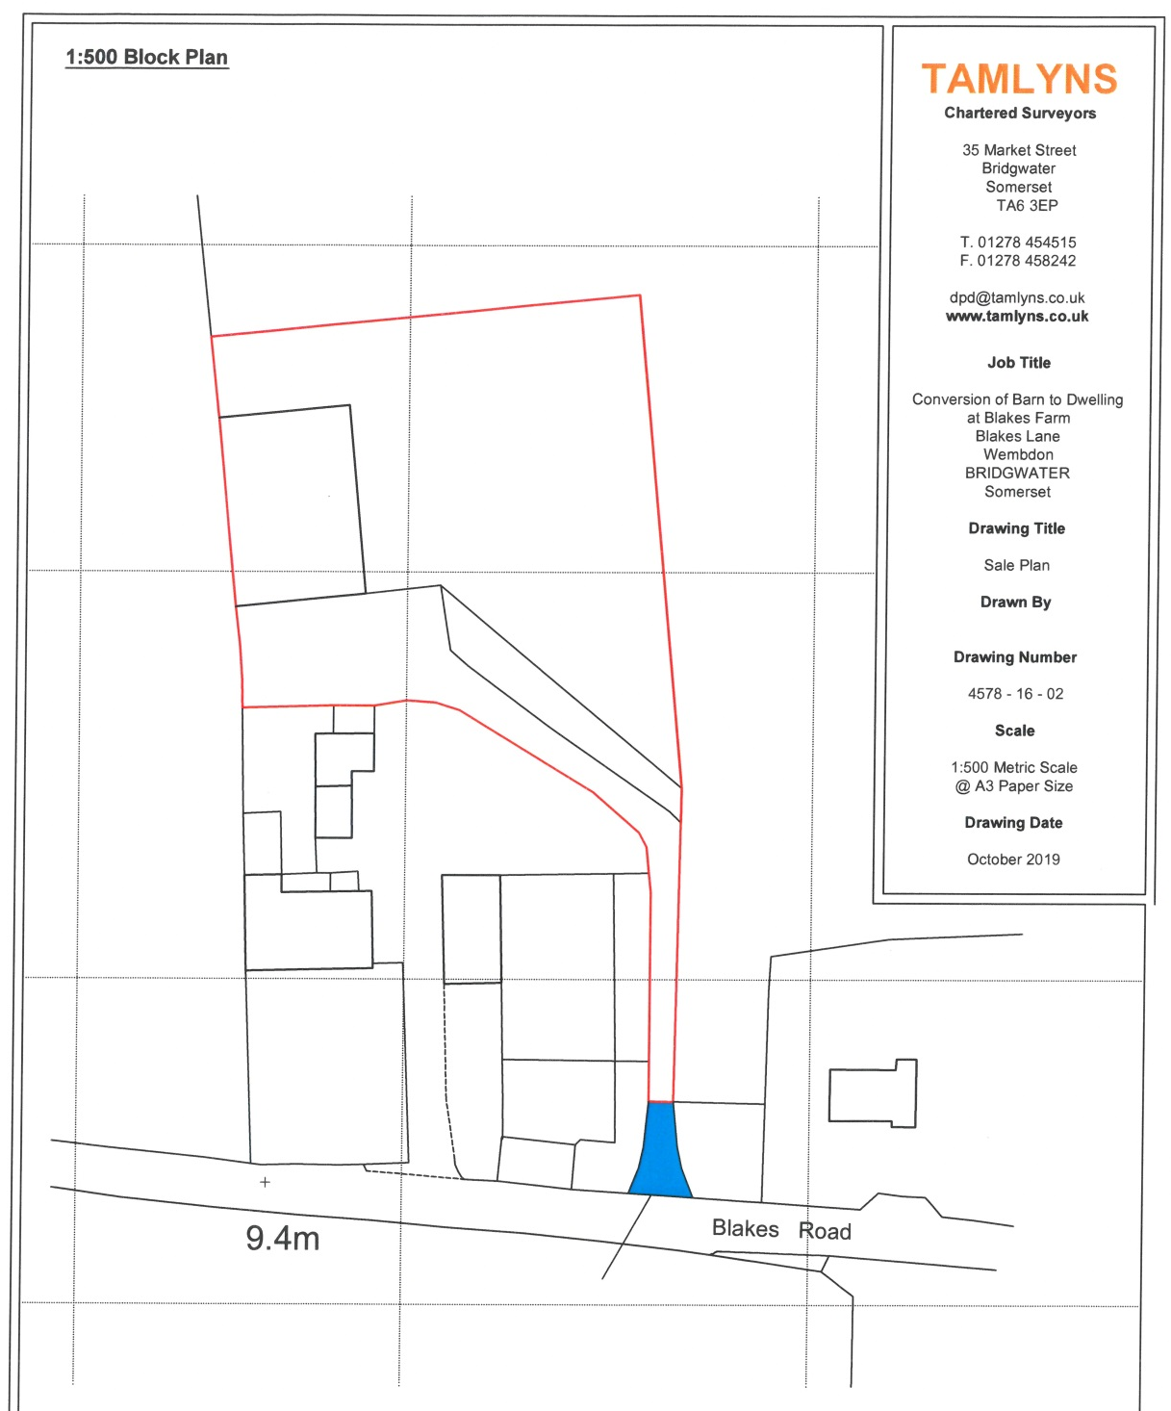

Plans – as submitted with Planning Application
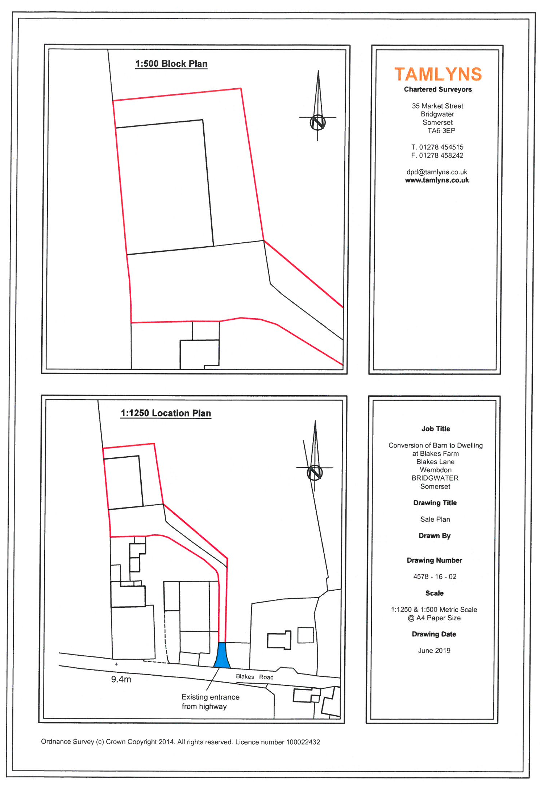

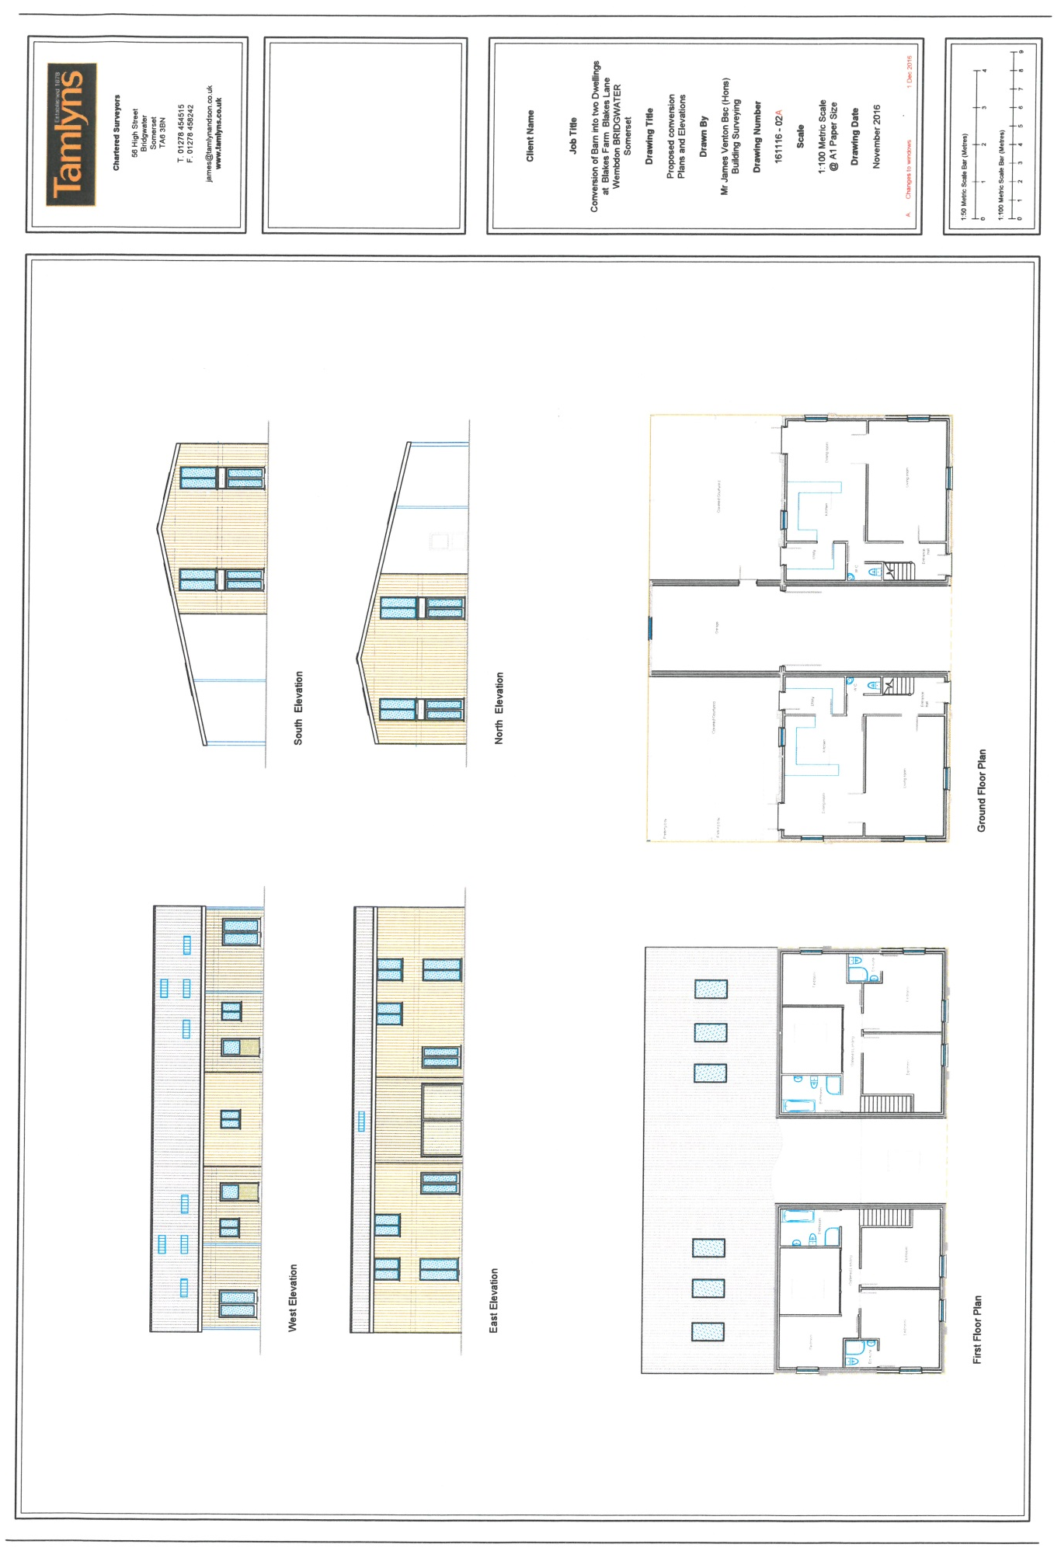

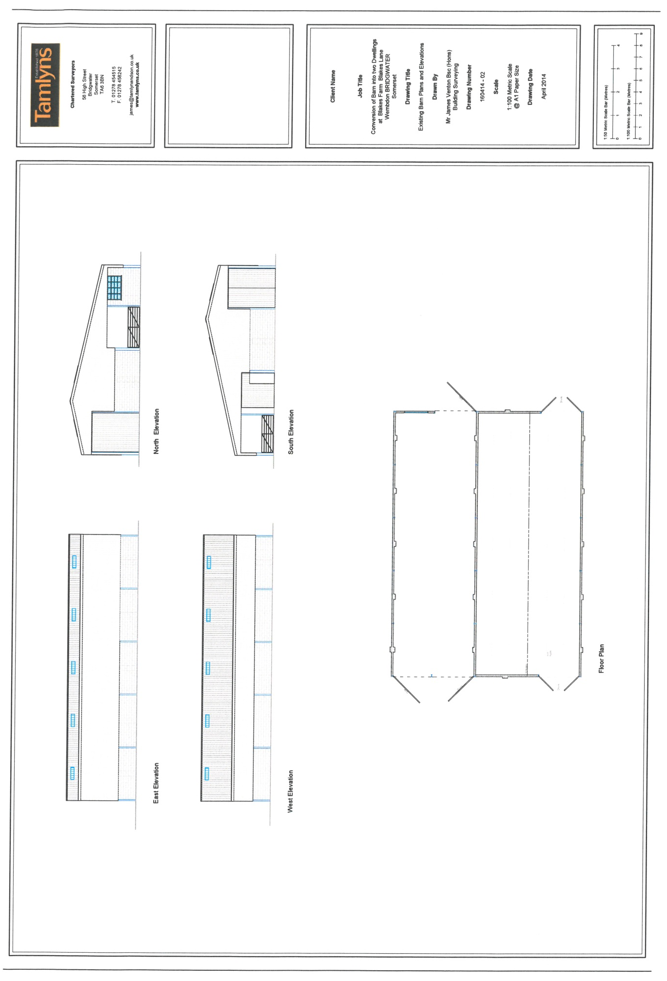

35 Market Street
Bridgwater, Somerset,
TA6 3EP
Telephone: 01278 458241

Email: agricultural@tamlyns.co.uk
Website: www.tamlynsprofessional.co.uk

