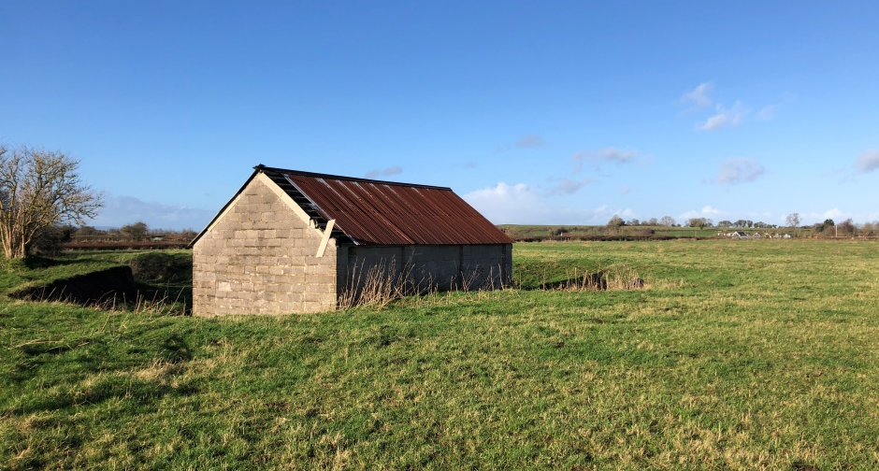
RURAL FARM BUILDING WITH PLANNING PERMISSION FOR CONVERSION INTO A SINGLE DWELLING SET WITHIN 3.7 ACRES

£150,000
OFF HOLLOWAY ROAD, MIDDLEZOY, SOMERSET, TA7 0PB

FOR SALE BY PRIVATE TREATY

Description

The sale of this property offers prospective purchasers the opportunity to acquire a single storey agricultural building with planning permission to create a single 2 bedroom dwelling, set within 3.7 acres. The land offers potential for a number of end uses including equestrian, a small holding or amenity land all subject to any relevant planning consents.

Situation

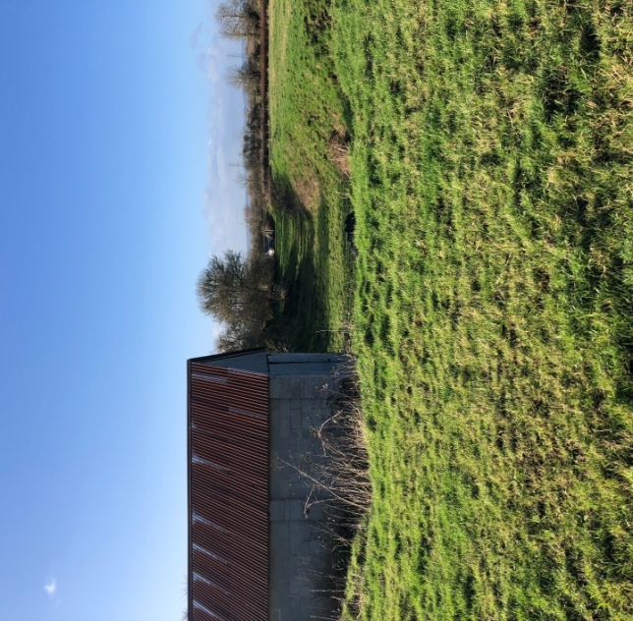
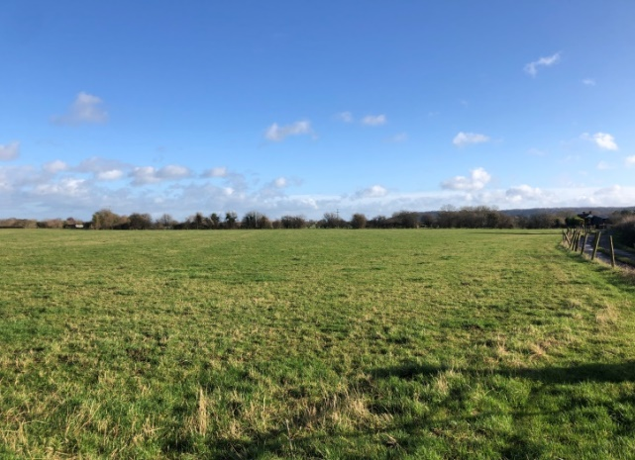
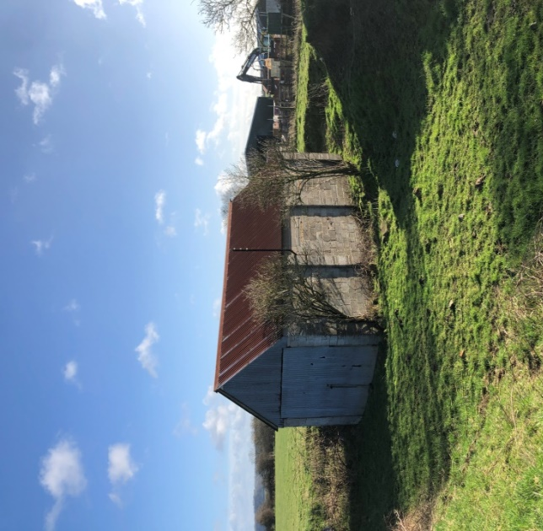
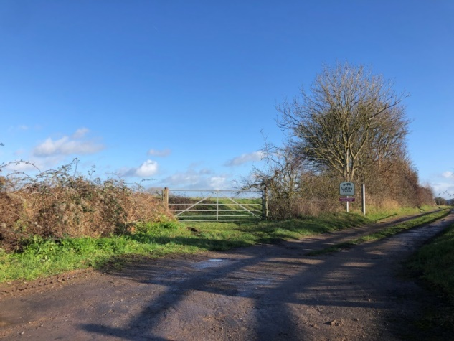
The barn is situated in a rural location approximately 0.5 miles from the village of Middlezoy which offers great local facilities including primary school, post office, village shop, Public House and Village Hall. The barn also falls in close proximity to the nearby towns of Bridgwater (6.5 miles) and the county town of Taunton (13 miles) which both offer a wide range of facilities and employment opportunities.

Town and Country Planning

Class Q Prior Approval consent was granted for the conversion of the building to form one 2 bedroom detached dwelling. Application number, 34/19/00014 granted on 18th November 2019.

Highways

The barn is accessed off Holloway Road. The field in which the barn sits is identified by a Tamlyns For Sale sign on the gate. Once at the field there is an already established track from the gate entrance to the barn.
Services

Potential purchasers are advised to make their own enquiries as to the availability of services.

Directions

If travelling North East out of Bridgwater follow the A372 for approximately 4.7 miles before you reach a cross roads for Middlezoy, where you turn right. Proceed through the village of Middlezoy for approximately 0.6 miles, until you come to the left hand turning for Holloway Road. Follow this road for 0.4 miles until you reach the entrance for Cutley Farm. Once at the entrance for Cutley Farm you will see the field and barn on the left when looking up the driveway, indicated by a Tamlyns For Sale board.

Conditions of Sale

A further condition of sale is imposed by the vendor in the form of a restrictive condition preventing the purchaser or his/her successors in title from forming any more than one residential unit of accommodation on the site as a whole.

A 1m high post and rail stock proof fence to be erected along the entire length of the northern boundary within 1 month of completion.

Community Infrastructure Levy

An exemption has been applied for by the existing owner and it has been confirmed by Sedgemoor District Council that there is no CIL obligation with regards to this barn conversion.

Should any prospective purchaser chose to change the planning permission, the Community Infrastructure may become applicable again.

Location Plan

Planning Drawings

The plans below are the plans submitted as part of the Class Q Planning Application. This first plan does not indicate the area of land offered for sale. The sale plan can be found later in these particulars.

Planning Decision

Wayleaves, Easements and Rights of Way
The property is sold subject to any Rights of Way, Wayleaves, Rights or Easements which exist at the time of sale whether they are mentioned in these particulars or not.

Local Authority
Sedgemoor District Council
Bridgwater House, King Square, Bridgwater, TA6 3AR
Telephone: 0300 303 7800

Tenure
Unless stated otherwise, the tenure is freehold and vacant possession will be given upon completion.

Method of Sale
The property is being offered for sale by Public Auction on 26th March 2020 7pm at Oak Tree Arena, Bristol Road, Edithmead, Highbridge, Somerset, TA9 4HA. Unless sold prior.

Money Laundering Regulations
In order to fulfil responsibilities under the Money Laundering Regulations all prospective bidders/purchasers will be asked to provide proof of identity. Acceptable documents include: Passport, full driving licence or birth certificate (at least one photo ID) as well as council tax, utility bills. For further guidance and acceptable combinations of documents please contact the office.

General Remarks
Viewing
The property may be viewed at any reasonable time. The selling agents will be pleased to meet any interested party on site by prior arranged appointment on 01278 458241 (option 1) or email us on agricultural@tamlyns.co.uk.

Services
Potential purchasers are advised to make their own enquires as to the availability of services.

Planning
Potential purchasers are advised to make their own enquires with the local district council on planning matters. Sedgemoor District Council, King Square Bridgwater, Somerset, TA6 3AR.

Sale Plan

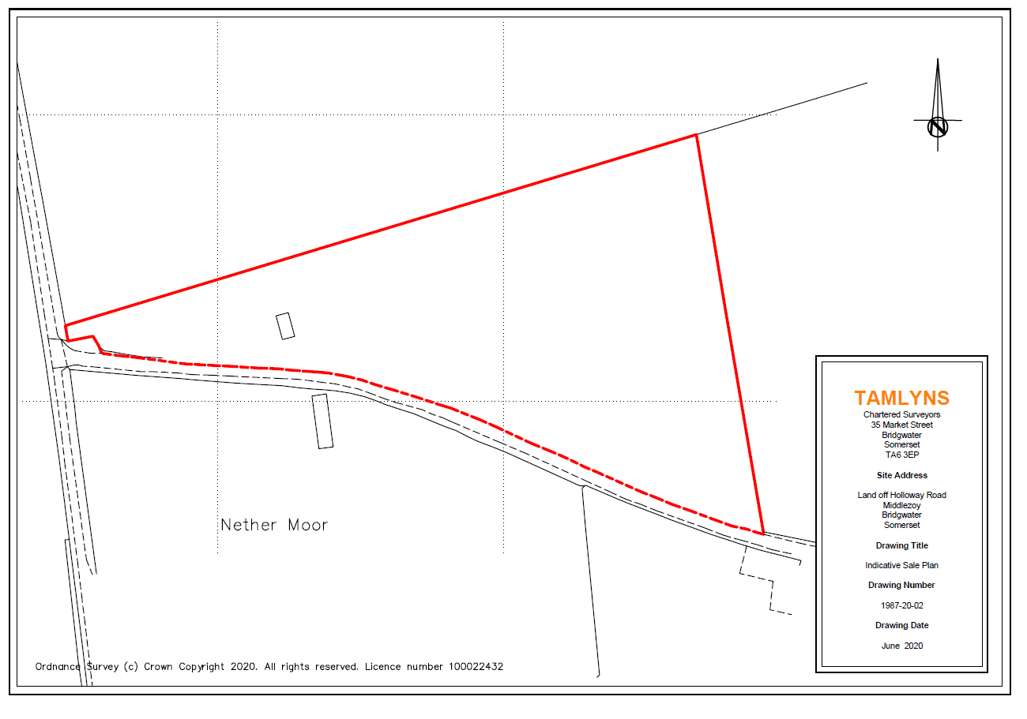

35 Market Street
Bridgwater, Somerset,
TA6 3EP
Telephone: 01278 458241

Email: agricultural@tamlyns.co.uk
Website: www.tamlynsprofessional.co.uk

