FOR SALE

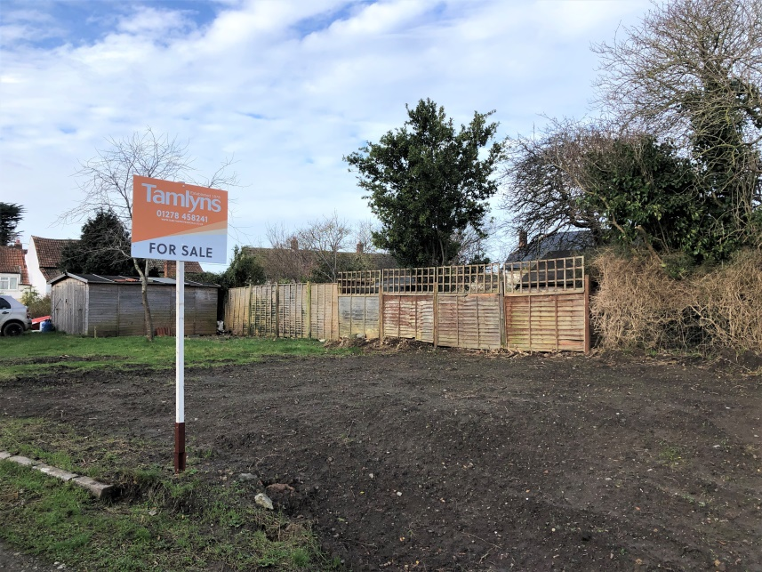

SINGLE BUILDING PLOT

AT

LAND OFF ST AUDRIES CLOSE
STOGURSEY
SOMERSET
TA5 1QU

FOR SALE
BY PRIVATE TREATY

Guide Price: £80,000 - £100,000
Description
A single building plot benefiting from outline planning permission for one new dwelling, located within the sought after historic village of Stogursey. The village benefits from a primary school, two pubs, church, village shop, local village events throughout the year and within 1 mile of the sea front.

Directions:
The land is best accessed via St Audries Close. This close can be accessed off Lime Street, which is off the main High Street running through the centre of Stogursey.
Stogursey is approximately 15km North West of the town Bridgwater along the A39 and approximately 23.5km to the north of Taunton, Somerset County Town.
Conditions of Sale:
Purchaser to erect new 1.8 meters close boarded timber boundary fence between point A, B & C (as per plan below), within two months of completion and prior to commencement of work to new dwelling.
Sold with vacant possession upon completion.
Plot Size:
The plot extends to approximately 11 meters x 23 meters.

Plan:
The plan incorporated at the rear of these sales particulars is for identification purposes only and where different from the contract plan, the latter should prevail.

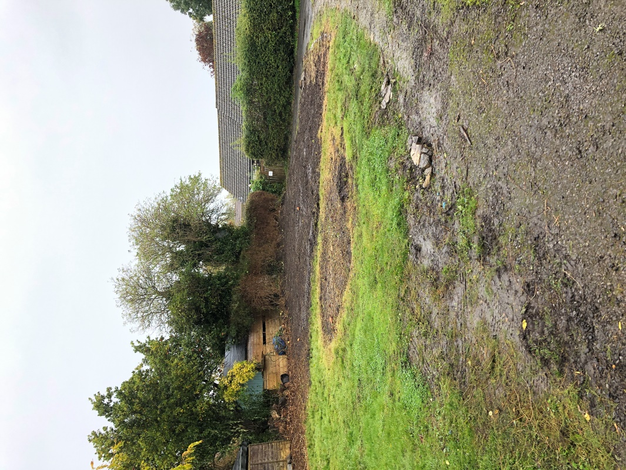

General Remarks

Services

Potential purchasers are advised to make their own enquiries as to the availability of any services.

The vendor is happy for the potential purchaser to lay services across his land at the potential purchasers own costs (including any repair required due to any damage caused during construction) and to the required Building Regulation Standards. The site will also be required to be returned to good afterwards.

Planning

Potential purchasers are advised to make their own enquiries with the local district council as to planning potential (if any).

Wayleaves, Easements and Rights of Way

The property is sold subject to any Rights of Way, Wayleaves, Rights or Easements which exist at the time of sale whether they are mentioned in these particulars or not.

Local Authority

West Somerset & Taunton Council.

West Somerset House, Killick Way, Williton, Somerset, TA4 4QA
Telephone: 0300 304 8000

Tenure
Freehold with vacant possession upon completion.

Method of Sale

The property is being offered for sale by Private Treaty.

Money Laundering Regulations

In order to fulfil responsibilities under the Money Laundering Regulations all prospective bidders/purchasers will be asked to provide proof of identity. Acceptable documents include: Passport, full driving licence or birth certificate (at least one photo ID) as well as council tax, utility bills. For further guidance and acceptable combinations of documents please contact the office.

Community Infrastructure Levy:
The site will be subject to the community infrastructure levy imposed by Somerset West and Taunton Council. The liability for payment of the levy will transfer to the purchaser upon completion of sale. Self-builders may be able to claim an exemption.
Responsibility for adhering to and complying with the community infrastructure and all associated conditions of said levy will lie solely with the purchaser.

Special Conditions of Sale

Tamlyns for themselves and the Vendors of the property, whose agents they are, give notice that:

1. These particulars do not constitute a contract nor any part of any contract.

2. All statements contained within these particulars as to this property are without responsibility on the part of Tamlyns or the Vendor.

3. None of the statements contained in these particulars as to this property are to be relied on as statement or representation of fact.

4. Any intending purchaser must satisfy himself/herself by inspection or otherwise as to the correctness of each of the statements contained in these particulars.

5. The Vendor does not make or give, and Tamlyns nor any person in their employment has any authority to make or give any representation or warranty whatsoever in relation to this property.

Viewing

The land may be viewed at any reasonable time with their particular details to hand.

Consumer Protection from Unfair Trading Regulations 2008

1) These particulars are set out for the interested parties and purchasers as a guideline only. They are intended to give a fair description but not to constitute an offer or contract.

2) All descriptions, dimensions, distances, orientations and other statements/facts are given in good faith but should not be relied upon as being a statement or representation of facts.

3) Nothing in these particulars shall be deemed to be a statement that the property is in good condition or otherwise nor that any services are in good working order. The agent has not tested any apparatus, equipment, fixtures and fittings or services and so cannot verify that they are in working order or fit for their purpose. Interested applicants are advised to make their own enquiries and investigations before finalising their offer to purchase.

4) The photographs appearing in these sales brochures show only certain parts and aspects of the property at the time the photographs were taken. Aspects may have been changed since the photographs were taken and it should not be assumed that the property remains precisely as displayed in the photographs. Items shown in photographs are not included unless specifically mentioned within the sales particulars. They may however be available by separate negotiation.

5) Any area measurements or distances referred to herein are approximate only.

6) Where there is reference in these particulars to the fact that alterations have been carried out, or that a particular use is made of any part of the property, this is not intended to be a statement that any necessary planning, building regulations or other consents have been obtained and these matters must be verified by any intending purchaser.

7) Descriptions of a property are inevitably subjective and the descriptions contained herein are used in good faith as an opinion and not by way of statement of fact. If there are any points of particular importance that need clarifying before viewing please do not hesitate to contact this office.

8) References to the tenure of a property are based on information supplied by the seller. The agent has not had sight of the title documents. A buyer is advised to obtain verification from a solicitor and before finalising their offer should make their own enquiries and investigations. Buyers should check the availability of any property and make an appointment to view before embarking on any journey to see a property.

35 Market Street
Bridgwater, Somerset,
TA6 3EP
Telephone: 01278 458241

Email: agricultural@tamlyns.co.uk
Website: www.tamlynsprofessional.co.uk

